**Bloggers**

Bloggers: aleksandr_skif, anna_news, bolshiepushki, boris_rozhin, epoddubny, ghost_of_novorossia, grey_zone, neoficialniybezsonov, opersvodki, readovkanews, RKadyrov_95, rsotmdivision, russ_orientalist, rybar, sashakots, Sladkov_plus, strelkovii, swodki, vladlentatarsky, vysokygovorit, wagnernew, warfakes, wargonzo, wehearfromyanina

Total bloggers: 24

**Posts**

|  |  |
| --- | --- |
| **Subsampling step** | **Number of posts** |
| Original | 841409 |
| Removed Soloviev | 676014 |
| Removed missing | 497780 |
| Wartime posts | 353129 |
| Pasted | 339846 |
| Putin mentioned | 9369 |

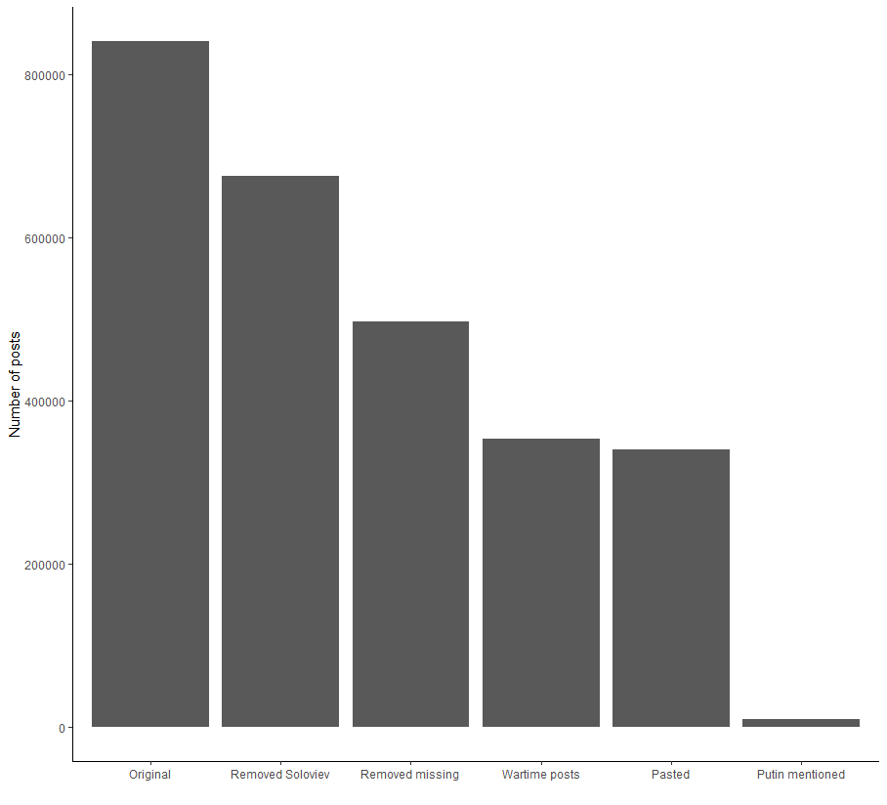

**Time frame**

01.01.2022 to 04.30.2023